“Free In Deed”
The Bi-Monthly newsletter of Central California Jail/Prison Ministry

Volume 5 - Sept 2004 / Oct. 2004

“I Can Only Imagine”

In this Volume 5 issue, we would like to remind of some of the articles we have presented.
Volume 1 –
Photo of Alcatraz Prison Cell
Confessions of a Chaplain
Testimonies of Fred and David
Ron’s Story

Volume 2 –
Photo of Disciples Prison Cell
Needs after Release
Recommended Reading

Volume 3 –
Story of Iris and Dwayne Blue
Review of previous articles

Volume 4 –
Guilty as Charged
Am I Really Saved?
Tools of Ministry
Testimony of James
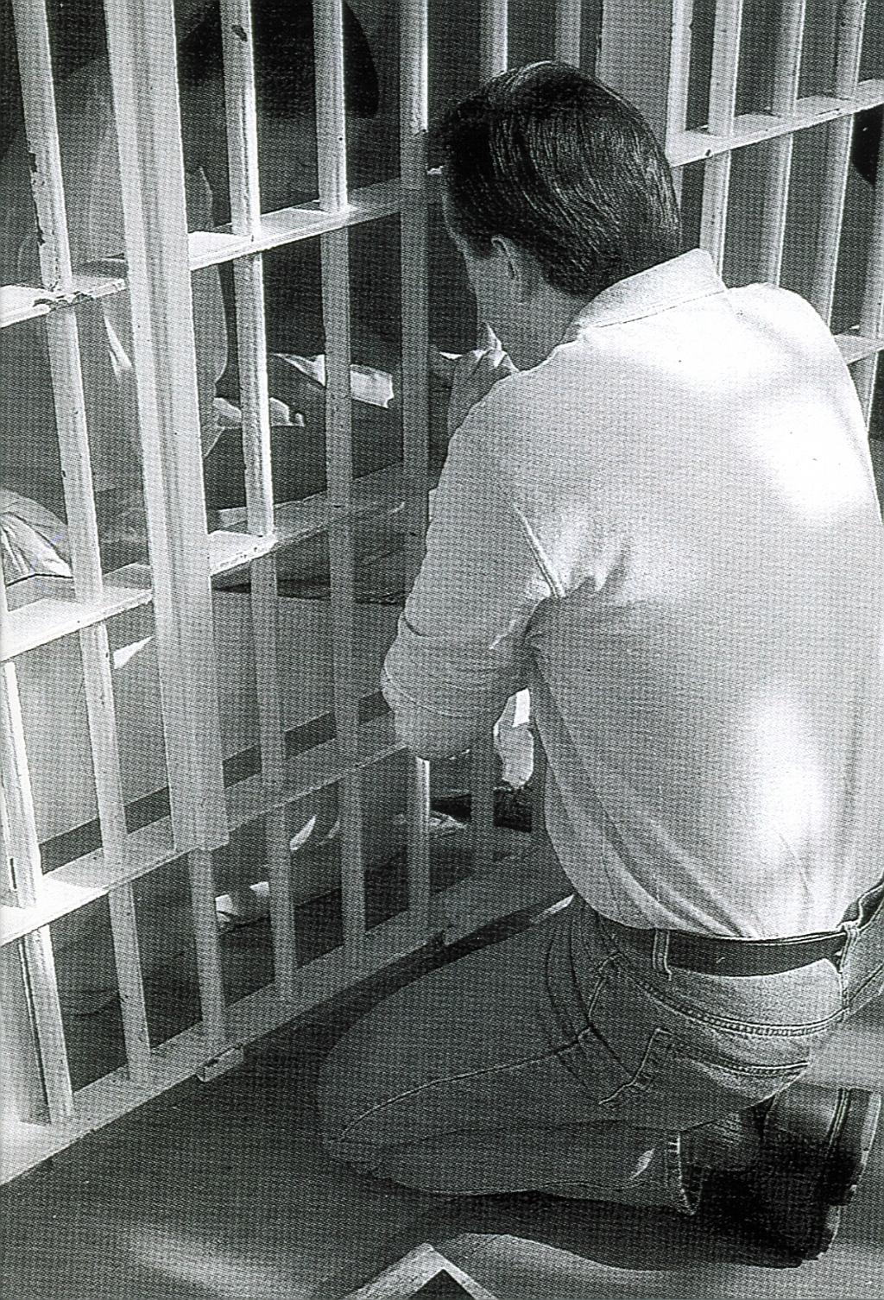
Intentions & Wishes
We have gone to Bi-Monthly because there is too much to share. The intentions of this newsletter are to allow an understanding of jail & prison ministries. It is our intentions to get input from those incarcerated as well as those “free” to visit. Life experiences of the faith and fellowship from those locked up in the facilities are always desired to let others know of the value of “visitation”. I am certain that each of us have many stories of the miracles God has done in our lives.
Our wishes are that we would have a list of supportive churches that individuals might look forward to attending once released.
A list of services, such as housing, employment, and counseling services, as well as some individuals available for friendly fellowship are also much needed items.
God’s Word says if a man stumbles, how can he continue lest there be another to help him up. Ecc. 4:10 “For if they fall, the one will lift up his fellow: but woe to him [that is] alone when he falleth; for [he hath] not another to help him up.” Proverbs 24:17 “Rejoice not when thy enemy falleth, and let not thy heart be glad when he stumbleth:” John 11:10 “But if a man walketh in the night, he stumbleth, because there is no light in him.”

Please help us with input for this news letter as we strive to serve God. We appreciate any articles or input.

Letters that Express it All

These are actual quotes from some of the different incarcerated individuals. The names have been removed

A life Spared

“. . I know without the Lord I probably wouldn’t be alive right now. It is because of the great Lord that I have left the dope game. Because of God, I still have my loving family, and I have two years clean from drugs. I read my Bible every day, I study it, and now I’m not in the gang, my life is great, I’ve accepted Jesus in my life, and there is nothing better. Now I’m filled with joy and happiness all around me. Thank you Jesus – WOOOOO!!! . . ”

Rededication to the Lord

“If I would not have ended up here, I never would have rededicated my life back to the Lord. There is one person I appreciated a lot. He has wrote to me, and keeps telling me to pray. He attends your church regularly. He is only 12 years or so, but I believe God used him to reach me, the lost. My whole mental aspect is different. I stay in the word daily and in here you see a lot of people that want to make sense of things. There are a couple of us now that help people get through their struggles. I do believe that God never gives you more than you can handle and he puts people in your path for you to help. I never feel alone anymore.

Tuning in on Him

“. . . I’ve been listening to your service on the radio about 2 or 3 months now. Every week I look so forward for it. Each week I take notes and do Bible studies on them, which are just so powerful to me. I have really grown in your studies and the Holy Spirit leading me. I now realize who I am in Christ and this world is just somewhere we are passing thru. That there is a bigger picture to everything, God’s picture. Of course by now you know I’m currently in prison. But I would never change what God has allowed to happen. I put myself here but for God to allow this to happen, has turned to such a blessing. I now have salvation through Christ Jesus. I used to believe just being an OK person was good enough for God. But He desires so much more and gives so much more
abundantly. I love God so much and God is so worthy to be praised“

As for me and my House . . .

I was richly blessed this Sunday Morning by your sermon, and I’ve decided it is time for me to give God my all. The good and the bad, the past and the future, relationships, job, friends, attitude, I mean all. I realize my all isn’t much, a big mess, but I am confident that if I seek God first and his righteousness, I’ll be OK. It is important for me where my family and I spend eternity. I choose God, in Jesus, in Heaven.

Something Gets in the Way

. . . I’ll do what you said about going to church. . . .I would like to go to your church and take . . . I would really like that to happen, but its going to be hard cause I don’t have a car and my drivers license is suspended cause of child support. You see ---, I want to be good. I’ve always tried to, but ther’s always something in the way to stop me from doing what I have to do that’s right. Why?

Translated from Spanish

I am answering your letter as soon as I received it because I was so happy that you wrote to me. For me it was a blessing from God to receive a letter like the one you sent because frankly you lifted my spirits. . . . You know the other day that you came and you prayed for me and my wife ------ and my son ----- I stayed with an utmost peace. Thank you Lord.

True Inspiration

. . . It is so true that we fail to see God’s plan. It’s like we put Him on the back burner a lot of times. When actually He should be the front burner at all times. Heck, He’s the flame for all the burners!

Need for Change

. . . Keep doing what you have been doing, and you will get what you have been getting.

Conversion

Conversion is the wiping of the slate clean so a new process can “start.”
Fellowship

We would like to keep a listing of locations for fellowship that welcomes previous incarcerated individuals. Please feel free to let us know of those available. We also cherish letters from inmates or relatives to the churches to let us know how we are doing

CHAINBREAKERS
Every Tuesday
Visalia First Assembly
3737 S. Akers
Visalia, CA.
Room 8 – 7:00 p.m.
733-9070 ext. 131

Calvary Chapel Visalia
11720 Avenue 264
Visalia, CA. 93277
687-0220

Visalia First Baptist
1100 S. Sowell
Visalia, CA. 93277
732-4787

Church of the Nazarene
3333 W. Caldwell Avenue
Visalia, CA 93277
734-1117

Praise Center Church
503 N. Floral St.
Visalia, CA. 93291
733-2744

If you would like a church added,
Please contact us.
Addresses to contact our Ministry Volunteers

Bob
P.O. Box 6667
Visalia, CA. 93290

Rick
3737 S. Akers
Visalia, CA. 93277

When Satan reminds you of your past, remind him of his future.

God accepts you where you are, but loves you too much to leave you there.

Bible Study Lessons

SET FREE PRISON MINISTRY
Of Northern California
401 MacArthur Boulevard
San Leandro, CA. 94577-9801

Replenishing

God’s Word promises to restore the years of the locust, or more simply the years previously lost.

Joel 2:25 And I will restore to you the years that the locust hath eaten, the cankerworm, and the caterpillar, and the palmerworm, my great army which I sent among you.
Recommended Reading

For the new Christian, or the individual desiring to know God, we would like to recommend the following reading.

The Gospel of John – This is a great introduction of Christ’s walk on Earth.

The Book of Romans – This gives an introduction of many of the Bible stories shared and helps build familiarity of Christ’s plan for our lives.

The Purpose Driven Life by Rick Warren – 40 chapters will change your life in 40 days

Book of Proverbs – Read one chapter a day with the chapter read being the day of the month. This will allow the book to be read almost 12 times thru the year.

Ephesians 4 – 6 – This gives the pattern for life that we should live. All 7 S’s are displayed in these 3 chapters. We are given the purpose of the gifts, changing our character, husband/wife/family relationships, and the type of life we are to live and display.

Men’s Relational Toolbox – Another fine work by Gary Smalley with both of his sons adding to this book. This book avoids “male bashing” but rather teaches men to use and modify the inner tools they have to improve their relationships.

Needs after Release

Individuals being released from incarceration have the same common needs of all individuals. There is a need of self-respect and self esteem. Many have a need of housing. Most are coming back looking for employment. Some are facing classes for AA, NA, or Domestic Violence. Some need to enroll in educational or vocational programs. Most would appreciate someone to just talk to or have a mentor. Fellowship with the right people is ALWAYS needed. For many these are totally new expectations and experiences.
One inmate expressed wonderfully the problem of being released. He stated that everything is slow to happen while incarcerated. It seems like an eternity as you wait for your next transfer or assignment. You feel like you are running at 5 miles per hour. Then, when released to the world, you are put into an environment that is running at 200 miles per hour. This drastic change of environments tends to overcome individuals and they have a hard time adapting. We hear of transitions from one area to another in each of our lives. Someone to just talk with about the feelings and changes the individuals are going thru is a great healer. The Bible says that each of us should be a “brother” to help the other one up when he falls. Other scripture talks about “sticking closer than a brother” we can often help with sharing life experiences or just listening to someone in need. We don’t always have to solve the problems, but many times need to just “lend an ear” so that someone might share their needs or hurts with us. Many men have heard from their wives “I don’t want you to fix it, just listen”. We need to just listen.

Tools of Ministry (Con’t)

Vol. 4 newsletter we started discussing the tools of ministry. We discussed such tools as a pair of Python Boots and a handcrafted one-of-a-kind car.
So, what about other “tools of ministry?” We already decided that they are more than the items such as the Bible, a concordance, a Bible dictionary, a pulpit, and a baptismal. Let’s continue with some more tools of ministry I have seen used or personally used.

Skydiving Parachute
Many people ask, “Why would you want to jump out of perfectly good airplanes.” Well, there are no perfectly good airplanes, just as there is no perfectly good world.
You might ask what does skydiving have to do with ministry. First there is the necessity to learn what you are doing if you want to survive. There is also the “fear of stepping out,” though a little different than stepping out in ministry. There is often more fear in stepping out in ministry than there is fear of stepping out of the airplane.
There is also the faith (or trust as it is sometimes called) in the person that packed the chute. There is faith that the equipment will function proper. There is faith in knowing what to do. And there is faith in just trusting God is in control.

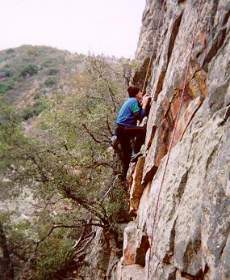
Rock Climb
We have heard it said that a person climbs a mountain “because it is there.” Most things that individuals get involved in are because of their love of it. However, this love for something is usually developed over time and becoming better at it. Think of how many testimonies we hear of a person that did not want to commit something to God, only to find them involved in it with an ever-growing passion. This individual is one who had said “NO” to jail ministry. He really missed out on a lot of blessings before.
How many other “tools” really are useable for ministry that God has entrusted us with? We will try to follow up with other examples in future newsletters.
Sharing Your Testimony

There are 4 parts to an individual’s testimony;
- What my life was like before I met Jesus
- How I realized I needed Jesus
- How I committed my life to Jesus
- The difference Jesus has made in my life.

But in reality, those who believe in Jesus have the testimony of God in them; Each of us needs to periodically share our testimony with others. The importance is not what you have done, but what God is doing.

- Your testimony;
- Your life lessons
- Your godly passions
- the Good News

God will make all things new
What are some things I should finish once I start?
"For if we are faithful to the end, trusting God just as firmly as when we first believed, we will share in all that belongs to Christ."
Hebrews 3:14
New life in Christ. We must maintain the confident faith we had when we first believed.
Scripture is from the New Living Translation (Tyndale House Publishers, 1996).

Testimonies

(Following testimony is from an inmate; translated from Spanish))

Mr. Bob
I am sending you a response to your most welcome and most appreciated letter and because you wrote back to me. Thank you for the photo to the little girl, she looks so pretty with her little dolls.
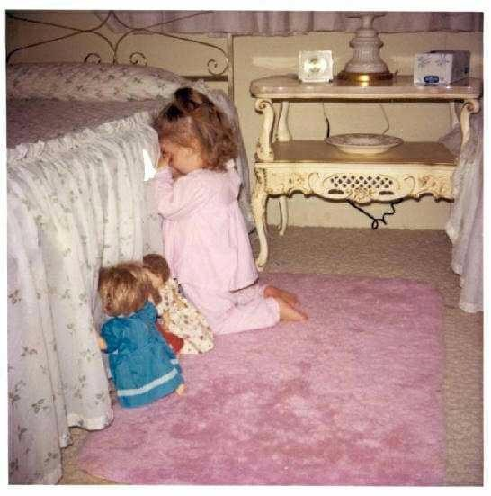
Why, she looks like an angel of God. Children are God's angels. Mr. Bob, I hope that you understand my letter because I do not write very well. I am going to write you in regards to what my life was like and the things that have happened to me. Hopefully this testimony will touch someone's life because I expect Glory thru Jesus Christ our Lord and what he has brought me from and the kind of life I have led.
My name is ------------ and this is my testimony. For eight years I was lost in the life of drugs and that is what has led me to be in prison. The other day I awoke up from my sleep and what came to mind was my wife and my son ----- who are my life and a blessing from God. The days passed and many things crossed my mind. I remembered all that hurt I inflicted on upon my wife and my son and the other people. It lay very heavy on my heart and I had to talk to someone but I felt to ignorant to know what to do. I knew there was a God but it didn't dawn on me to speak to him. Now I know and remember the day that Jesus Christ came into my life.
First of all I want to tell you about the bad illness I had with fever. It was very, very bad and only with medicine and injections would it get better but Jesus Christ was my doctor. It was on Christmas Day at 3 o'clock in the morning and I had already had 3 days being very sick here in prison. I had tonsillitis and much fever I had the worst painful headache that I could not sleep and felt like my head was going to explode from the pain. I could not even eat for 3 days due to my inflamed tonsils, fever and lying down from the tremendous pain. What came to my mind was that I was being punished because I had never experienced such terrible pain. I began to ask God, in the middle of my painful ordeal, to please forgive me of all that I had done to offend Him and others to deserve this punishment and for Him to take it away from me because it was too much to bear. It was then while speaking to God it dawned on me that painful headache had left me and I began to cry as I continued to ask for forgiveness laying down because I could not get on my knees from being so weak.
The main thing is that when I finished talking and confessing all of me I felt a healing in my heart and did not even remember falling into a most restful sleep. After the 3 days without eating, not resting and distressed with pain, I awoke very early without pain, without fever although my body was drenched from the sweat but very hungry even though weak I had Jesus Christ in my heart. God gave me a brand new heart.
Now that God has given me a new opportunity and new life I will not abandon Him because he never abandoned me. Even though I was what I was he loves me and I love my wife ------ and my son ----- who are a blessing from God to me and more precious is the gift that He has given me of a new life. The old Me died so a new Me could be born with a new heart that our Lord Jesus Christ gave me.
It is almost my time to be released God willing. I will be out on ---------- and I will be happy to be with my wife and son. I have a beautiful wife and a precious 2 year old and I love them very much. Now I have a treasure in my heart.
My desire with the Lord's guidance is to be obedient and share the word of God and it will have to start with my own family. Then it will be Christ who is my guiding Light.
I still have much to let you know about what God is to me in my life. I could not even express in words the magnificence of God's love and how much he has for all of us.
May God bless you and your family,

The Power of Biblical Friendships

Reprinted from May 17, 2004
Dr. James MacDonald

“The righteous should choose his friends carefully.” (Proverbs 12:26)

On the broadcast for the last several weeks, we’ve been engaged in the study, “I Really Want to Change . . . So Help Me God!” When I present these truths in a church or a Bible conference setting, the response is overwhelming. Perhaps in your past experience, you too have experienced the transforming power of God as never have before. Yet you would admit that you found victory only for a time and then fell back into a pattern of defeat. Maybe you got fired up at a youth retreat or a special conference or during a difficult time, and for once you were really walking in the joy of the Lord, but then it all fell apart. You are not alone! Most Christians today are not living at the peak of their spiritual experience. They know how to fire it up, but they don’t know how to keep it going.

I want to talk to you today about how to keep it going. The Christian life is not a solo thing. It requires teamwork. Today’s topic is how to download the incredible resource God has given us in our brothers and sisters in Christ. We desperately need each other so that when we want to quit we can’t because our friends “won’t allow it!”

Let’s begin with this thought:

Lasting change requires biblical friendship.

The key word in this statement is biblical, because not all friendships are biblical. In fact, some are very unbiblical. They not only do not help us, they impede our progress on the pathway toward transformation. Instead we need biblical friendships. After almost twenty years as a pastor, I can tell you that people who change—people who develop a life pattern of change, becoming more and more mature as followers of Christ—are surrounded by biblical friendships. Without those kind of friendships, they cannot flourish spiritually. Neither can you.

Change does not happen in a silo. On the broadcast we’ve been talking about change as though you could get it done standing inside a big cement cylinder. I may have given you the picture that transformation was just you and God. Maybe you have been seeing yourself with Bible open, eyes turned upward, and the Spirit of God filling you—just you and God, and change happens. That is not a complete picture! We cannot flourish spiritually in the long-term without each other.

It’s time to knock the silo down and begin to pay attention to the people that God has placed around you as resources for change. That is why God has called together this thing called the local church.

Friendships in the Scriptures
“The righteous should choose his friends carefully, for the way of the wicked leads them astray,” Solomon wrote (Proverbs 12:26). As you read God’s Word, you cannot help but notice that great men and great women of faith always had supportive friends around them. Always!

Think of Abraham, who had Sarah, his loving wife and good friend. Yes, she made some mistakes, but Hebrews 11 tells us that she was a woman of faith. She stuck with Abraham through thick and thin. Without the loving, supportive cooperation of Sarah, Abe would have had a much harder time following God’s call.

Think of Moses, whose life cannot be understood apart from the role of supportive relationships. Moses had Aaron, his brother, to speak for him, and his father-in-law, Jethro, to provide leadership consultation on the proper way to delegate authority. He had Miriam, his sister, to stand with him when the people rebelled.

Moses’ friendships extended beyond his family. He also had Joshua and Caleb. When everyone else doubted, these partners in faith supported Moses’ claim that the children of Israel could conquer the land. (See Numbers 13:1–3; 23–14:9.) Moses experienced firsthand the prosperity of biblical friendship.

The list could go on and on. Ruth and Naomi gave sacrificially of themselves to one another. Esther, alone and tempted so far from her natural surroundings, flourished in faith because she had this solid, caring friend, Mordecai. David and Jonathan became soul brothers. Elijah and Elisha, two prophets under attack, lifted each other up.

In the New Testament, Paul had Barnabas, who supported him when everyone else feared the former persecutor of Christians (Acts 9:27–28; 11:25–26). He also had Silas, who joined him in song, even though they were in prison (Acts 16:22–25); and Timothy, who would give comfort when Paul was again imprisoned near the end of his ministry (2 Timothy 4:13, 21). Peter had John; John had Peter. And, of course, Jesus had twelve close companions and when He sent them out to do ministry, He sent them “two by two.” When He sent out seventy ministers (Luke 10), again He sent them two by two. Why? Because of the power of biblical friendship.

Some of the greatest disasters in all of God’s Word came because people had the wrong (unbiblical) friends, or no friends at all. Eve’s biggest problem was Adam. Adam’s biggest problem was Eve. They didn’t help each other. One of them should have said to the other one, “What are you thinking?!? Put that down! Don’t bite that!”

King Saul had Samuel sent by God to help him be all God wanted him to be. Saul’s problem was that he didn’t listen. He had a biblical friend but refused to listen to him and, as a result, his life ended in tragedy. David’s downfall was directly related to the lack of biblical counsel he received from his military leader and friend, Joab. The general refused to challenge David after the king gave orders to cause Uriah’s death in battle (2 Samuel 11:14–15). Instead of warning the king against being an accessory to murder, Joab stayed silent.

No friends can be as damaging upon our thoughts and actions as unbiblical friends. Think of Jacob and the incredible potential of his life. In almost every instance Jacob was alone when he did some very foolish things. He deceived his brother; he lied to his father, and he ran from his problems. And how about Samson? You want to talk potential: Handsome and strong, he had a full understanding of the power of God. The Spirit of God was resting upon him (Judges 13:24–25; 14:6, 19). But his life was foolish and ultimately tragic, and in every passage we learn about him, he is alone.

We are just like the men and women in God’s Word. We have abilities and a desire for God and great potential, but without
biblical, truth-telling friends, our lives will flop just like theirs. Choose friends who are committed to change. You cannot go where God wants you to go unless you hook up with somebody who also wants to be what God wants him or her to be. It’s a two-way thing. Change flourishes when it’s a partnership. So choose friends who are committed to change.


Being a Man of Vision

Many have listened to the radio ministry of “Thru the Bible” by J. Vernon McGee. This radio ministry is more alive today than it was when it was started. Surprising to many that listen, is the fact that J. Vernon McGee died about 15 years ago.
J. Vernon McGee realized that the ministry was not about him but was about God. McGee’s main request was that he would be involved in a ministry that would lead continue on, possibly even through the Tribulation period to lead the lost as well as the saved.
For those familiar with the Promise Keepers ministry, we remember there were themes that were titled “A man of Honor,” and “A man of the Spirit, a Man of the Word.” Looking at the messages of these themes, we realize that man is the subject of the sentence, BUT God, honor, spirit, and Word are the objects of the sentence.

The word says in Proverbs 29:18, “Where [there is] no vision, the people perish: but he that keepeth the law, happy [is] he.”

As a Christian, we need to remember “It is not about me, it is about Him (Christ).” The things we do should not bring glory to us, but should bring glory to Christ and his ministry. The effects of the things we do should be positive thru all eternity.
It is natural for us to have a fear of the dark when we are young. As we grow older, we hopefully learn how to overcome this. In order for proper vision, there must be light. Jesus said “I am the light.” For us to be “A Man of Vision,” we must dwell in the “Light” and remember whom we serve.
A Christian cannot be a Believer without a hunger for things of the Lord; but there can appear to be a hunger without being a believer. Check your desires and commitment !!

Excuses of Sin

Sin is something we must confront head on. As with most things we hate to deal with, there is a tendency to “put off” dealing with sin in our lives. There are 5 reasons we make excuses and do not deal with sin.

Denial
When confronted with the fact that we may be living in sin, we will say “What sin?”

I John 1:10 If we say that we have not sinned, we make Him a liar, and His word is not in us.

He who says he is without sin, is a liar, and the truth is not within him.

I John 2:4 He that saith, I know him, and keepeth not his commandments, is a liar, and the truth is not in him.

I John 2:22 Who is a liar but he that denieth that Jesus is the Christ? He is antichrist, that denieth the Father and the Son.

Avoidance
Many times individuals will ignore the confrontation. Sometimes there is the avoidance by “Are you talking to me?” We need to avoid the situations of sin rather than avoiding the confrontation of sin. When confrontation comes our way out of love, we need to embrace the solutions and those bringing the solutions.

Blame Shift
Justification is often used to avoid dealing with sin. This justification, or blame shifting, is directed to others as the reason for our failing. How often do we hear, “It was because of the people I was with, they made me.”

Rationalize
Ever heard the phrase “Everybody does that?” We tend to rationalize that we are no worse than the majority of the people. We start doing comparisons of what others have done, and decide that we are not that bad. Rationalization can also be done in the opposite direction when we tend to pull up the “good things” a person has done in order to avoid confronting the sin in their life. Parents often will talk only about the accomplishments of their children and try to rationalize away the sin as being minor. In reality, sin is the major thing in our life that we must deal with.

Prov. 16:25 There is a way that seemeth right unto a man, but the end thereof [are] the ways of death.

Excuses
Another justification method is the one of excuses. Have you ever heard the statement, “Well you don’t understand what I have been through?” We make excuses because of environment, circumstances, troubled times, and even say “that is the way things were when I was growing up.”

Proper option would be “I did it” and am “guilty as charged.” God can only forgive those things that we are guilty of. If we do not admit guilt and turn away from the sins (repentance), God does not forgive. If we continue with our sins because of not being forgiven, we are not saved. The accepting of continuing on in the habitual sinning is different than the occasional sins we repent of

